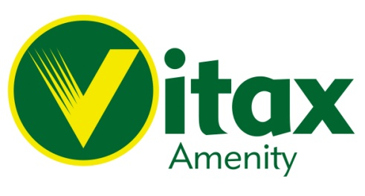
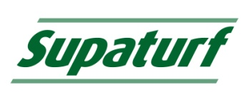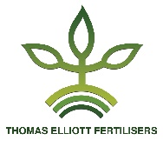
Turf Tonic

What
Turf Tonic is a compound fertiliser which is ideal for all year-round use.
- Homogenous even sized granules for even nutrient distribution.
- Stimulates early season growth.
- Replenishes nutrients lost through late season growth.
- Used as part of a moss control programme.
- Suitable for all sports, amenity and domestic lawn use.
Why
Turf Tonic from Vitax Amenity, offers professional results, both by stimulating early Spring growth and in Autumn by replenishing nutrients lost through late season growth while reducing Moss infestation and improving plant disease resistance.
- Stimulates plant growth and regeneration without the risk of excessive growth.
- Can be used all year round as part of a planned turf management programme.
- Source of nutrients essential to stimulate healthy growth.
- “Hardens turf” to help reinforce playing surface’s and improve disease resistance.
- Late Winter/Early Spring application for an early start to Spring Turf renovations.

When

Can be used all year round as part of a managed turf programme, or as an early spring growth stimulant or for Autumn and Winter nutrient replenishment.

Best results may be achieved when soils are moist, try to avoid periods of prolonged dry conditions.

Application

Recommended application rate of 35kg/1000m² (35gms/M²).

For heavy moss infestations seek advice.

Formulation

2.1 N: 0 P: 2.5 K + 3% Fe

